**E1 Operating System**

User Manual

11/30/2014 *Date of last edit

**Concord University, CS 361**

Ioan George Istrate

Table of contents

Interface overview 3

Interface command buttons 4

Interface written commands 9

**Interface Overview**

Once installation, and setup for the E1 operating system is completed (setup, and installation documentation will be the subject of the ‘Setup, and Installation Manual’ as available), the user will be prompted on the Welcome Screen to press the right ctrl key.

Once the right control key is pressed the Command Interface is visible as shown below:

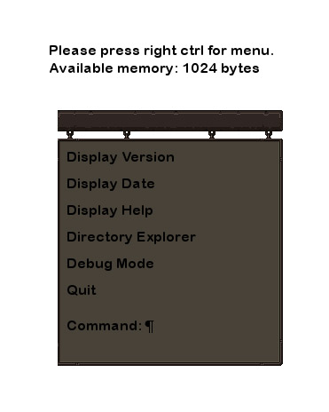

The Command Interface is where all of the action takes place. At first glance we can see the buttons for Display Version, Display Date. Display Help, Directory Explorer, Debug Mode, Quit, and the Written Command interface.

**Interface Command Buttons**

1. **Display Version**

Once clicked, the Display Version button will update the screen to show the current version of the E1 operating system.

The version number will be displayed on the top left as shown in the following figure.

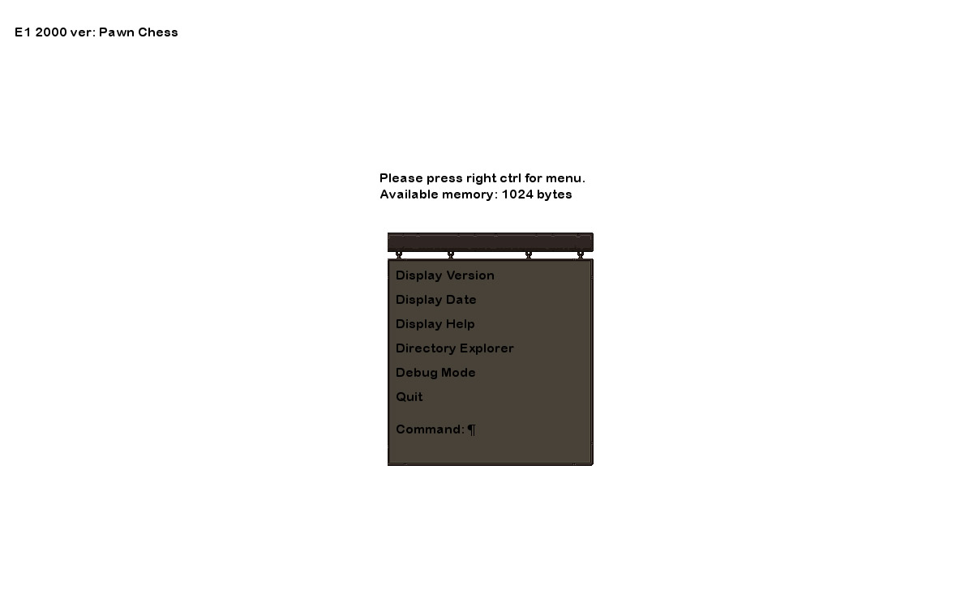

1. **Display Date**

When the Display Date button is clicked the current date will be displayed on the top left, right above the version number. Please see figure below for example.

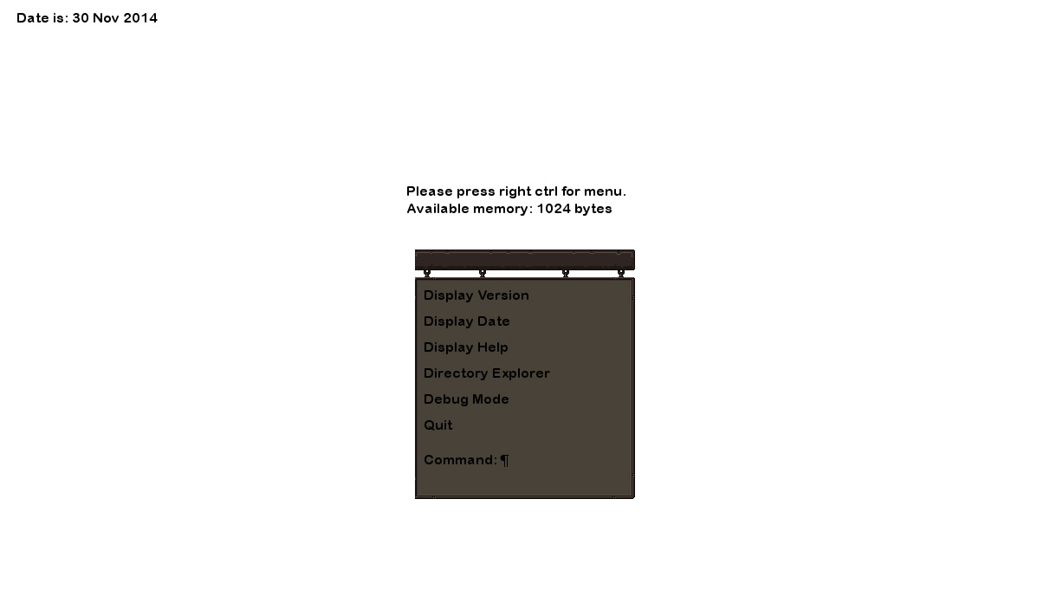

1. **Display Help**

If you need to see a quick overview of these instructions you can always click on the Display Help button, which will bring up an overview of instructions.

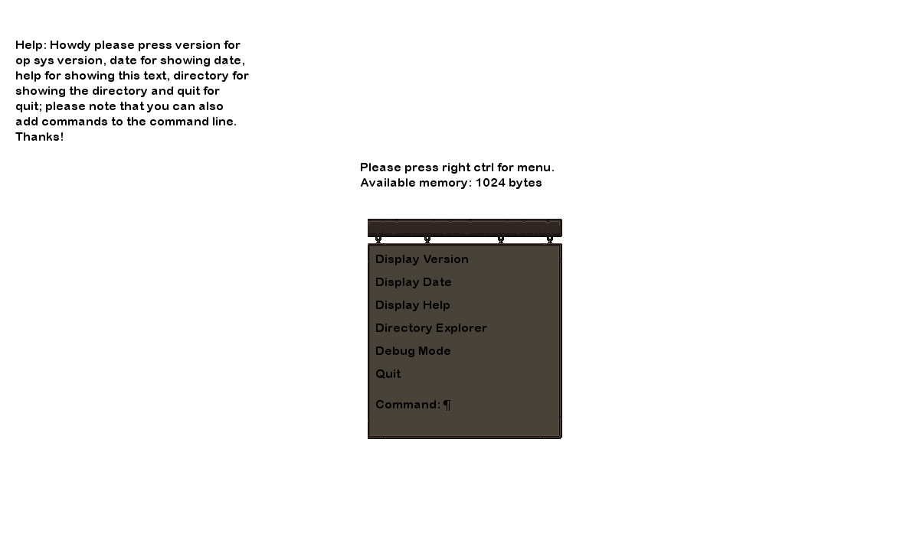

1. **Directory Explorer**

The Directory Explorer command will bring up the contents of the current working directory.

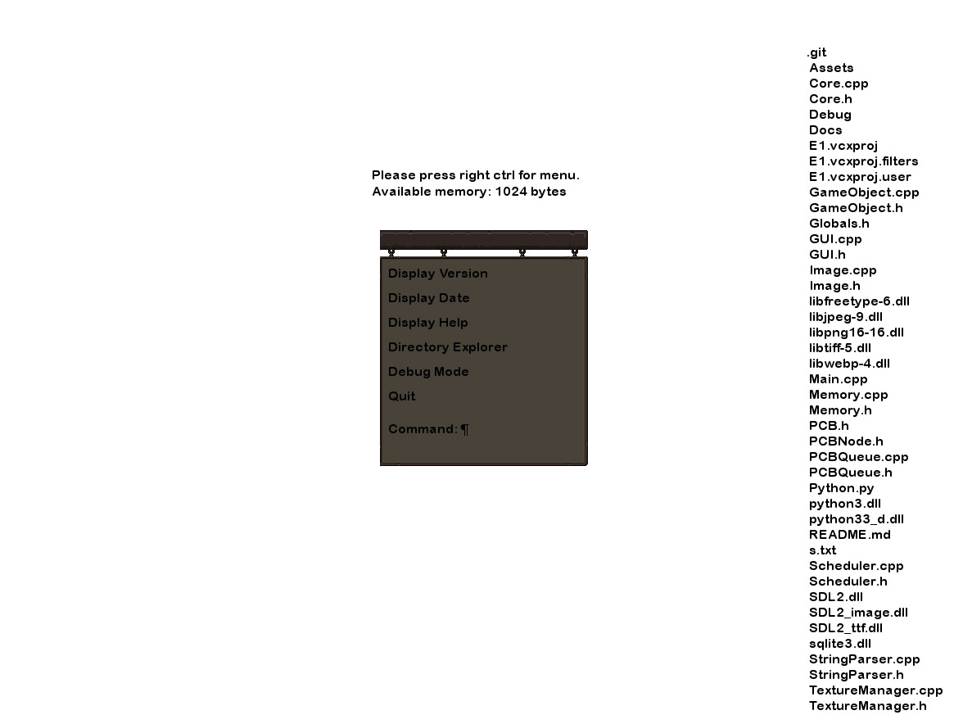

1. **Debug Mode**

For people interested for a glance in how the system processes commands, there exist a debug mode. When clicked, the Debug Mode button will reveal information on two screens, the current operating screen and the command prompt screen.

Information displayed are:

* Command - shows a number that corresponds to the action the user has taken, it mostly deals with the mouse buttons.
* Turn – shows the total frames that have passed since the operating system has started.
* FPS – Frame per seconds
* X (and a number) – shows the cursor x coordinate
* Y (and a number) – shows the cursor y coordinate

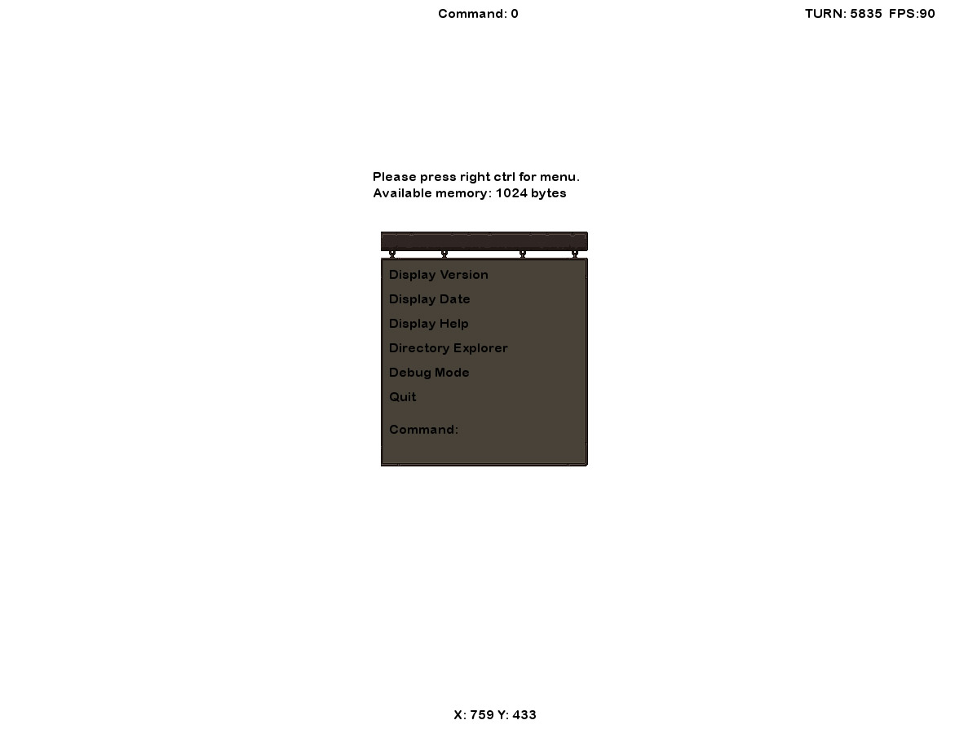

When debug mode is started, test processes (referred from now on as PCB’s) are launched and tested. The information on the command prompt screen show:

* The Test PCB class 1 for App and 0 for System
* The PCB name
* The PCB state
* The PCB priority

Other information shown is for PCB queues removal and insertion as well.

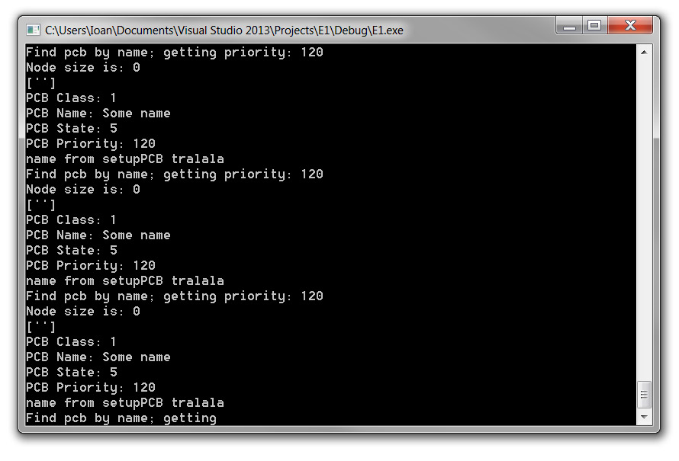

1. **Quit**

On pressing quit, all processes are stopped, and the operating system shuts down.

**Interface Written Command**

For advanced users, we have provided a command line. Please note that you can enter commands even when the panel is not opened, the commands will always be visible in the command prompt screen.

The commands written in the command line are as follows:

1. CreatePCB <name> <class> <priority>

a. Allocates and sets up a new PCB and inserts it into the Ready Queue

b. Need to get the following info from the user:

i. Process Name

ii. Class

iii. Priority

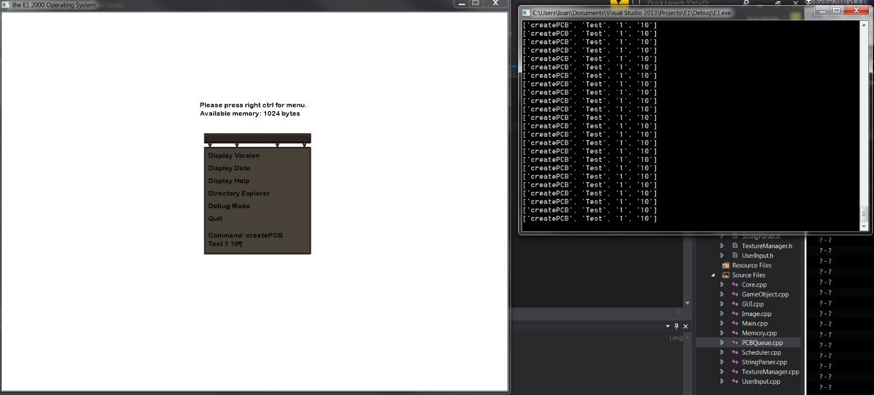

2. DeletePCB <name>

a. Removes an existing PCB from its queue and frees its memory

b. Get the PCB name from the user

3. Block <name>

a. Get PCB name from the user

b. Places the process (PCB) in the blocked state

c. Does not change its suspended status

d. Removes the process from the ready queue and place the process in the

blocked queue.

4. Unblock <name>

a. Gets process name from the user

b. Places the process (PCB) in the ready state

c. Does not change its suspended status

5. Suspend <name>

a. Get PCB name from the user

b. Puts the PCB in the suspended state

6. Resume <name>

a. Puts process in not suspended state

7. Setpriority <name> <priority>

a. Get PCB name and new priority from user

b. Sets PCB priority

8. ShowPCB <name>

a. Get PCB name from the user

b. Display all information about the PCB

All show commands will be open up the show info interface on the top left side.

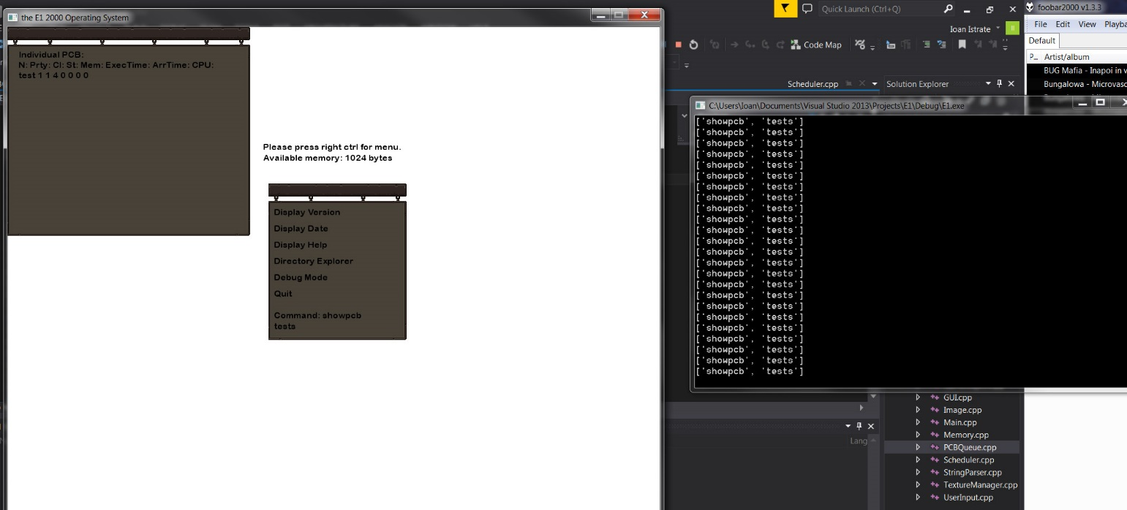

9. Showall

a. Show information for all PCB’s in all queues, in any convenient order

10. Showready

a. Show processes in the ready state

11. Showblocked

a. Same as showready, except show the processes in the blocked state

12. Showcompleted

a. same as showblocked, except it shows the processes in completed state.

13. Showrunning

a. same as showblocked, except it shows the processes in running state.

14. Hide

The hide command will close the show info interface.

**IMPORTANT! In order to run processes you need to use the command Dispatch. The 15 to 21 commands only load the processes into memory!**

15. Fifo <filename>

Ex: Fifo s (s is the default filename)

Fifo loads processes for the First In First Out process scheduling. It shows the processes in the ready state inside the info interface located top left.

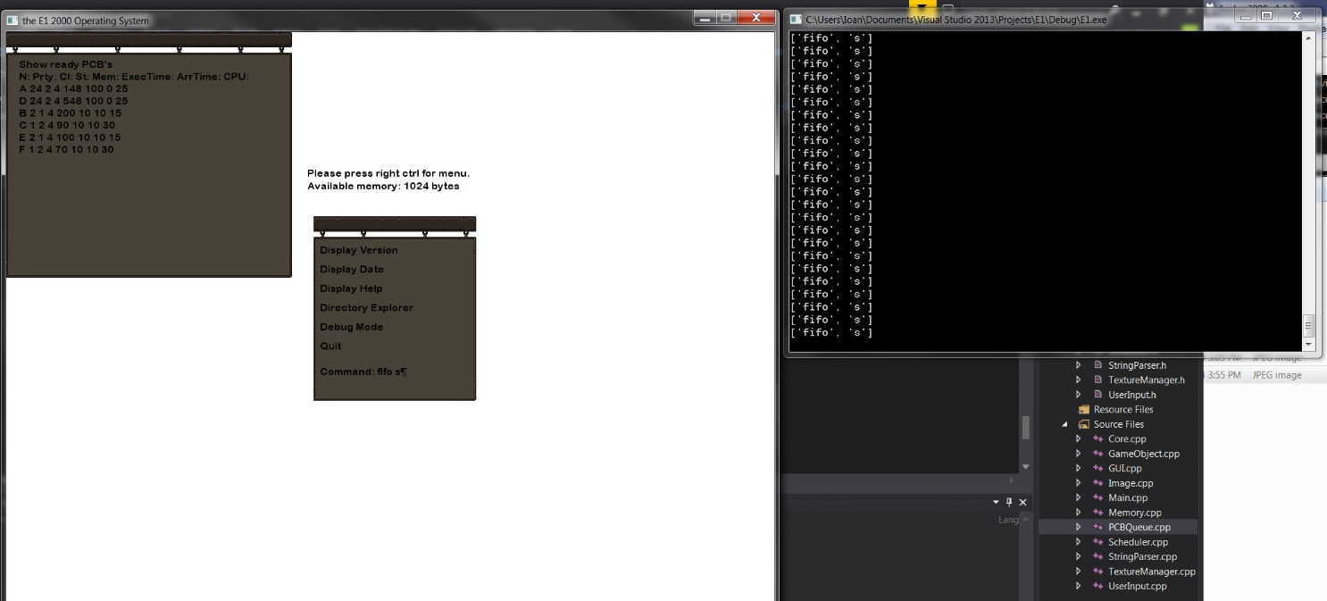

16. SJF <filename>

For example please see 15. Fifo

SJF loads processes for the Shortest Job First process scheduling. It shows the processes in the ready state inside the info interface located top left.

17. STCF <filename>

For example please see 15. Fifo

STCF loads processes for the Shortest Time To Completion First process scheduling. It shows the processes in the ready state inside the info interface located top left.

18. FPPS <filename>

For example please see 15. Fifo

FPPS loads processes for the Preemptive First process scheduling. It shows the processes in the ready state inside the info interface located top left.

19. RR <filename> <timeslot>

For example please see 15. Fifo

RR loads processes for the Round Robin process scheduling. It shows the processes in the ready state inside the info interface located top left.

20. MLFQ <filename> <queues> <timeslot> <cycles>

For example please see 15. Fifo

MLFQ loads processes for the Multilevel Feedback Queue process scheduling. It shows the processes in the ready state inside the info interface located top left.

21. LS <filename> <tickets>

For example please see 15. Fifo

LS loads processes for the Lottery process scheduling. It shows the processes in the ready state inside the info interface located top left.

**IMPORTANT! In order to run processes you need to use the command Dispatch. The 15 to 21 commands only load the processes into memory!**

22. Dispatch

Dispatch is needed before any processes can be run. Dispatch alters 3 views, the completed and running views, and the available memory right above the command interface.

Example showing the information while processes are running.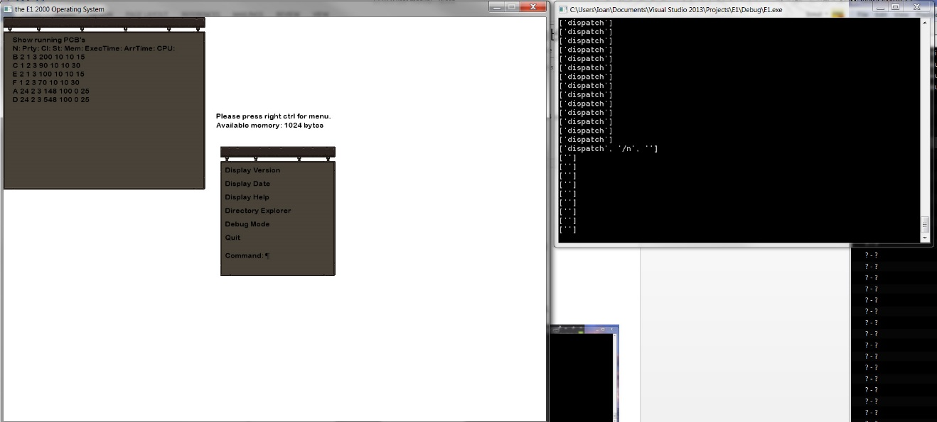

Example showing the information once the dispatch command has been completed.

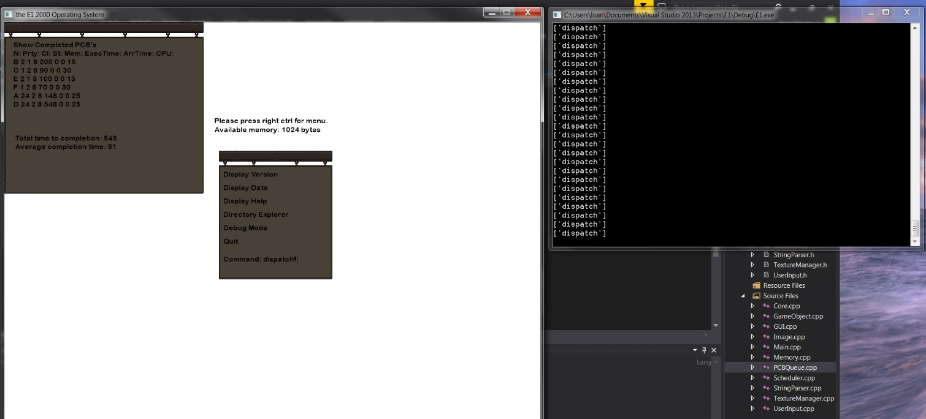

23. ClearCompleted

In order to clear the completed queue, you need to enter the clearcompleted command. This will allow you to run another batch of processes with the 15-21 commands followed by 22.

The end